CN Lab 4
Lab Exercise:

GNS3 Network Topology:
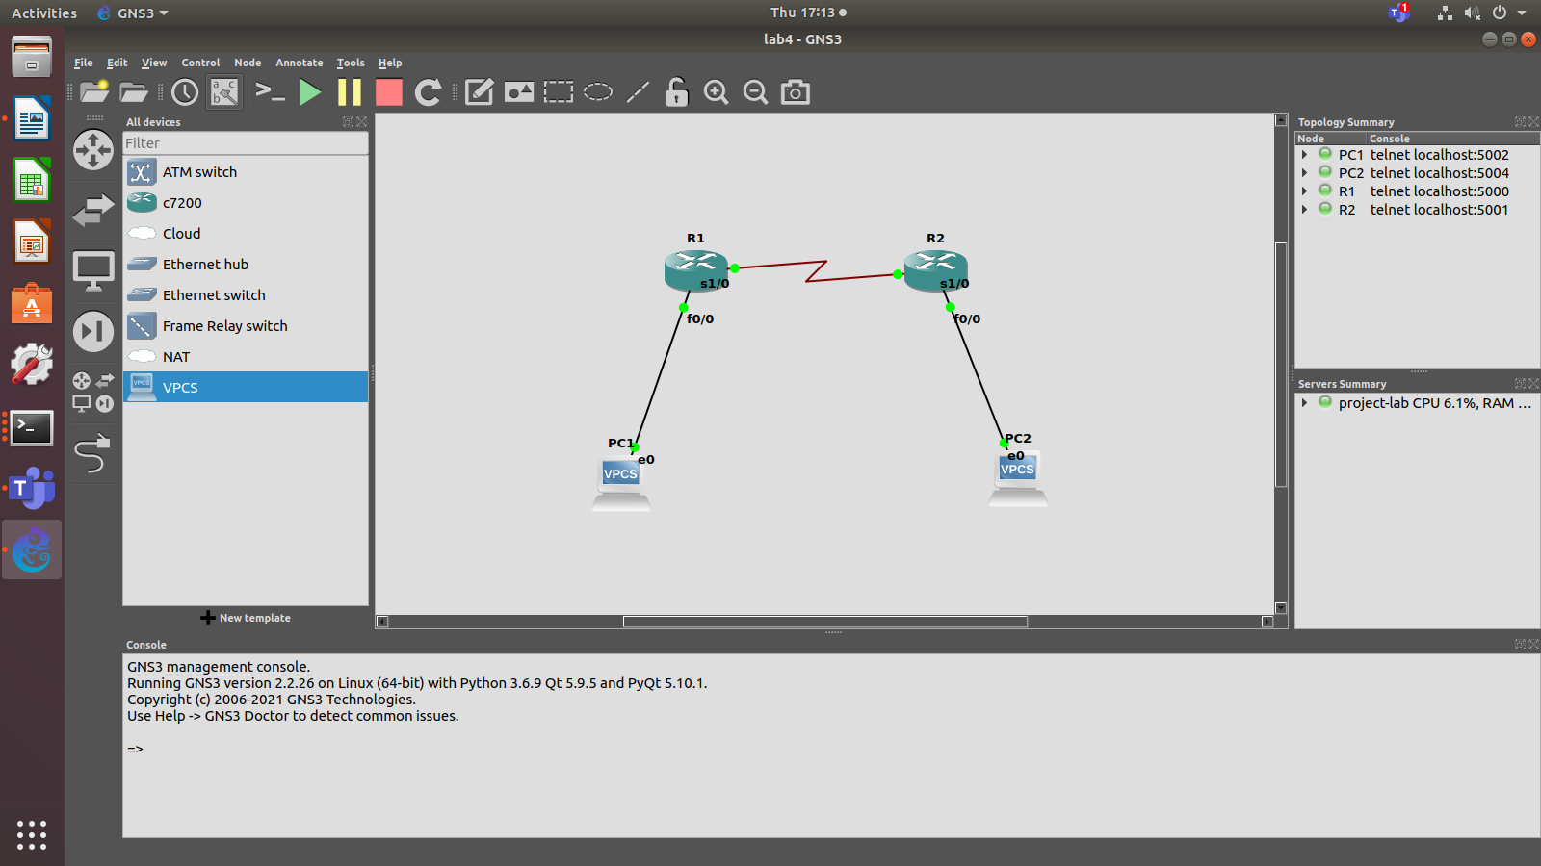
Initially when we ping PC2 from PC1 we get a timeout. That is because the routers haven’t been configured with the destinations ip address yet.

Router 1:
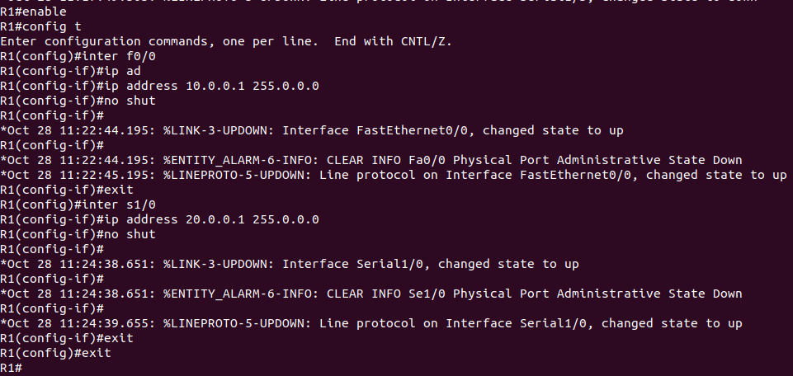
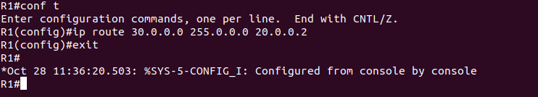

Router 2:
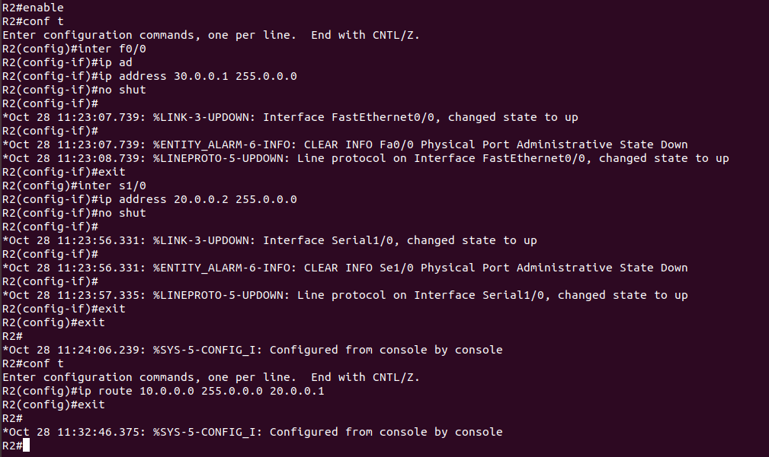

PC1:
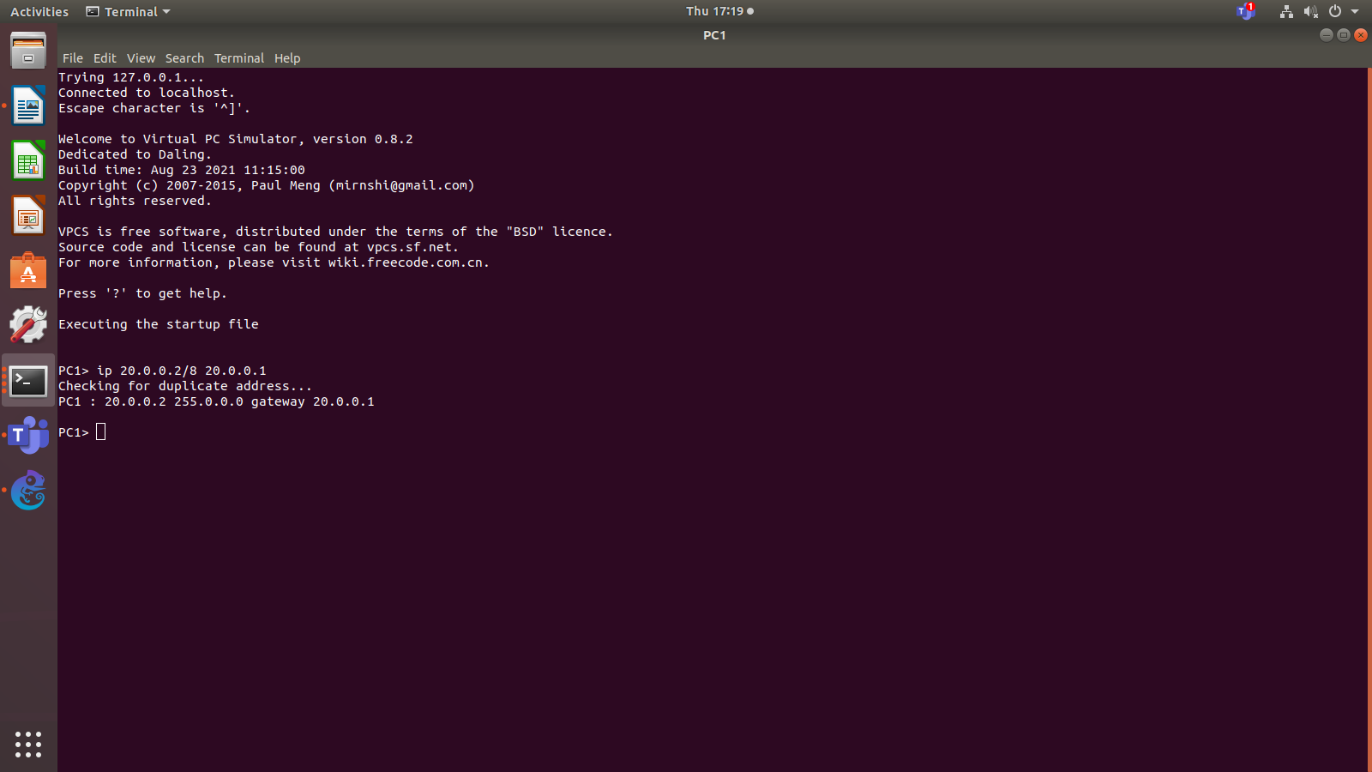

PC2:
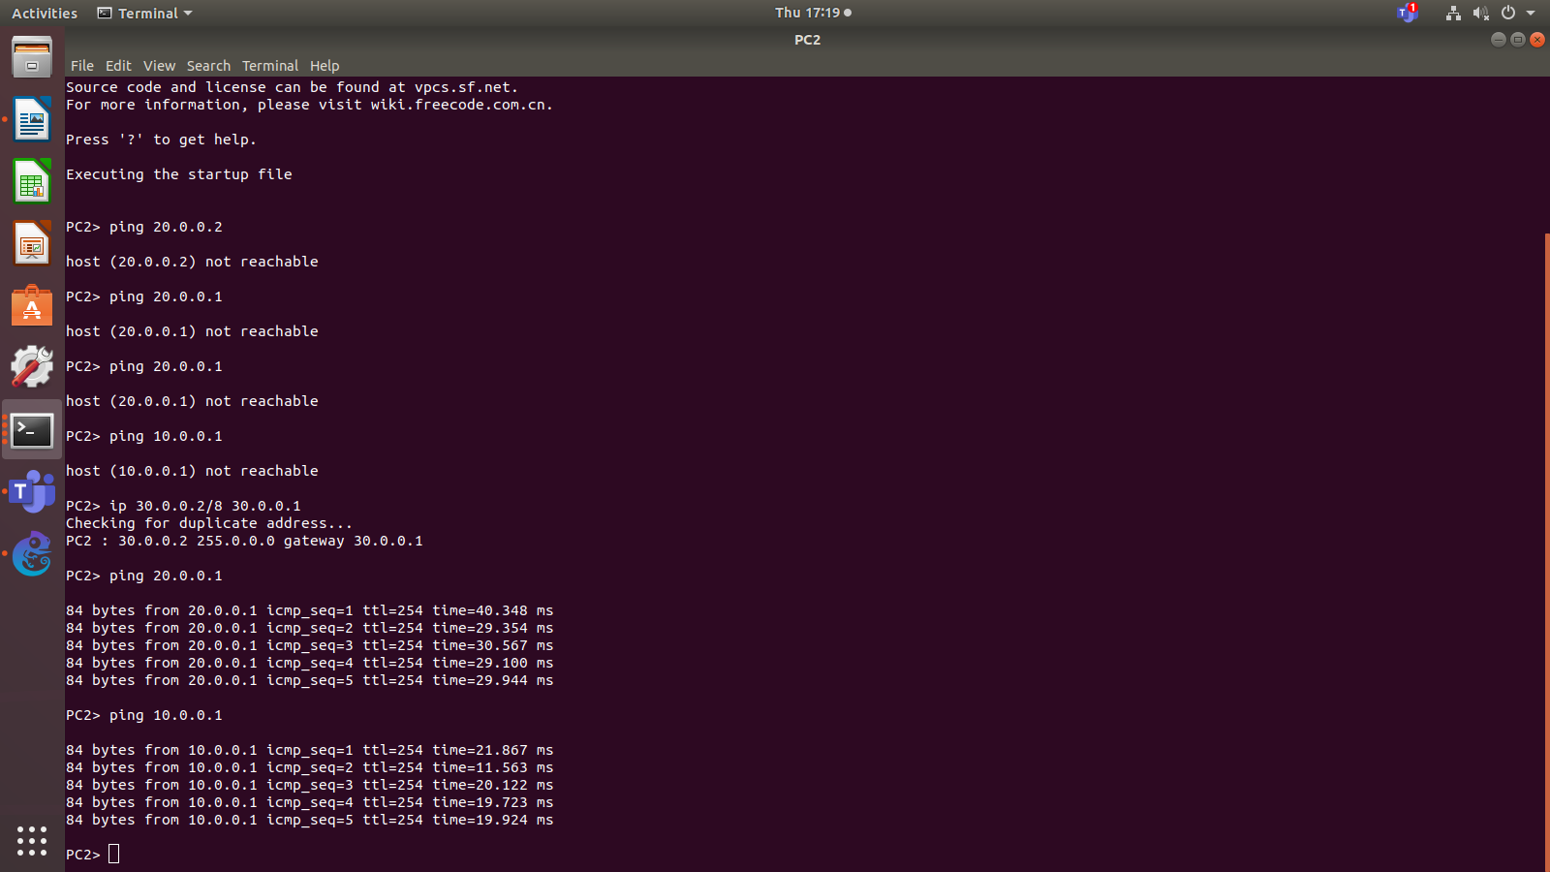

Wireshark capture when pinging PC1 from PC2.
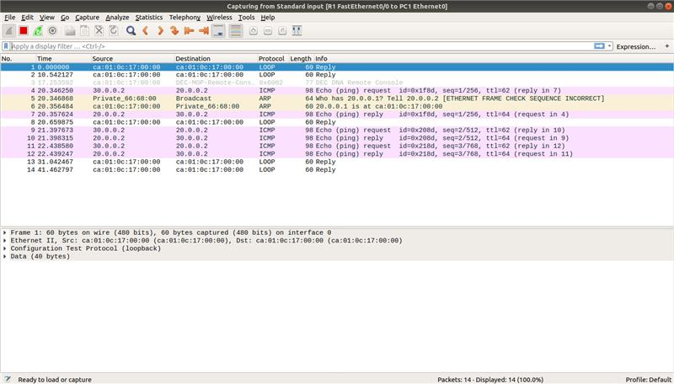

We can see ICMP messages which means that the communications between the 2 PCs is successful.

Additional Exercise:
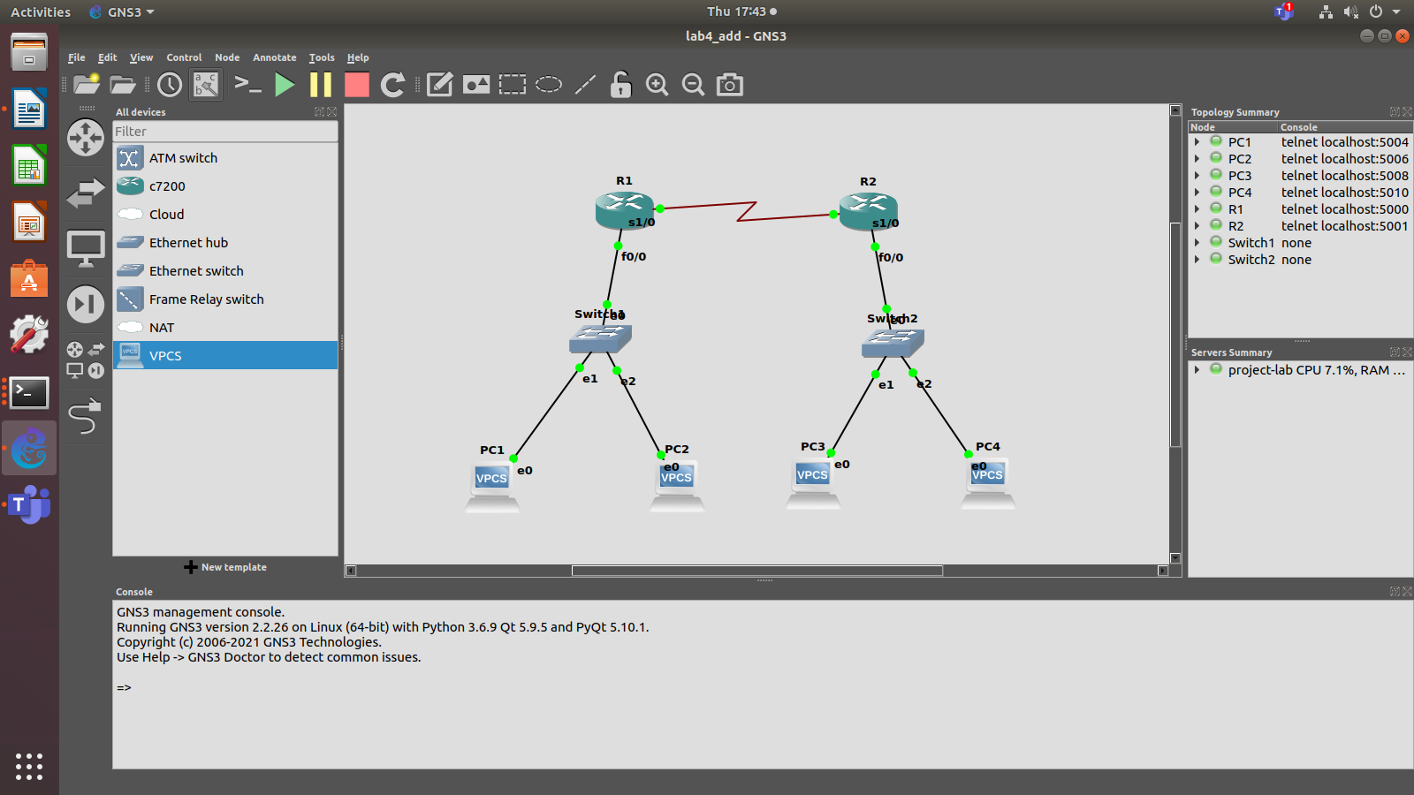

IP routing is not needed for PC1 to communicate with PC2

PC1:
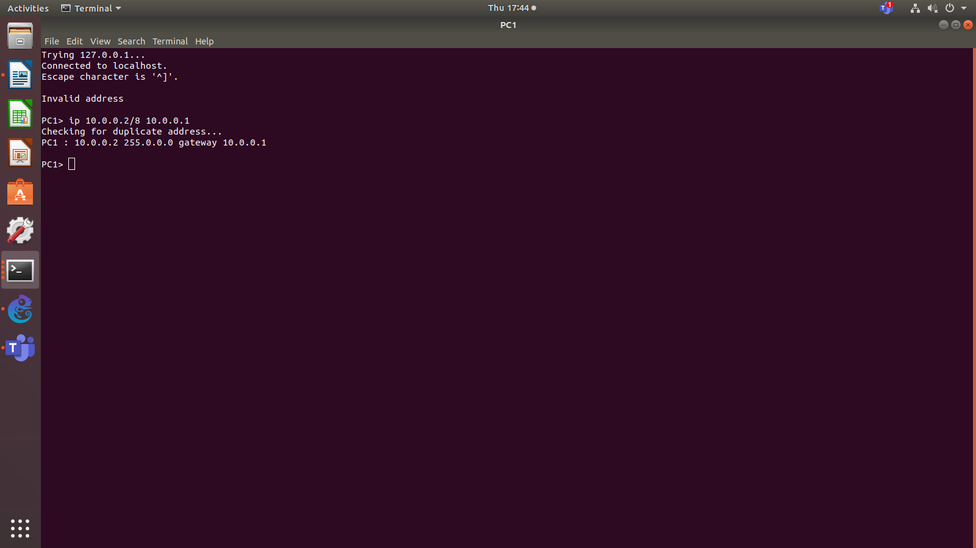

PC2:
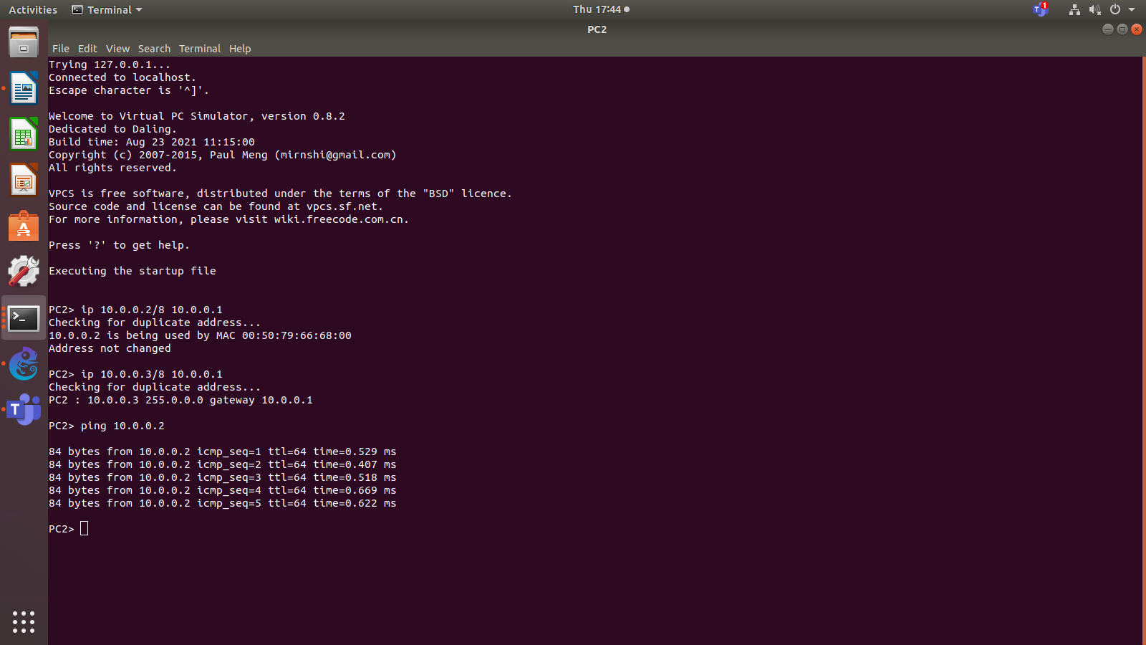
Router 1:
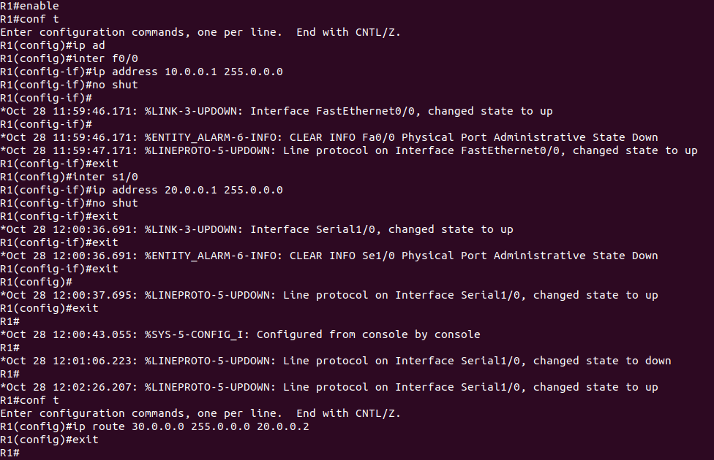

Router 2:
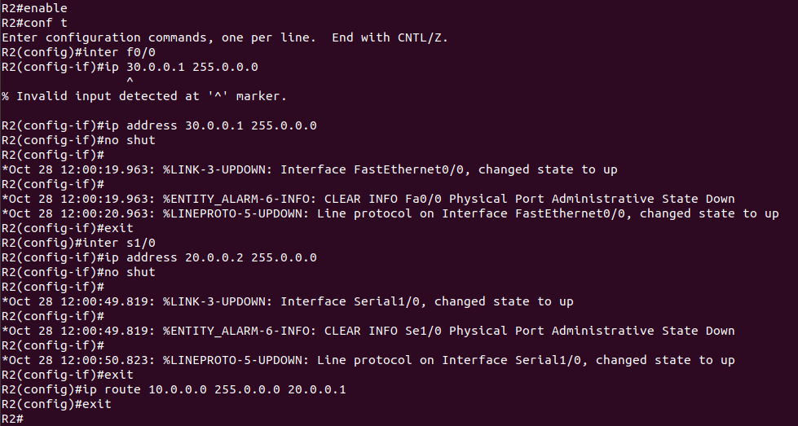

PC3:
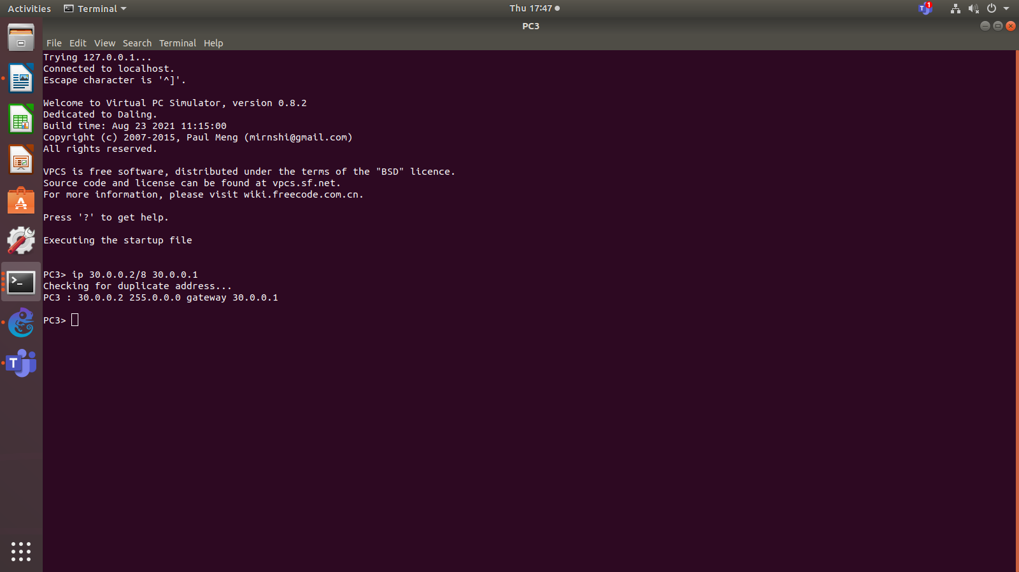

PC4:
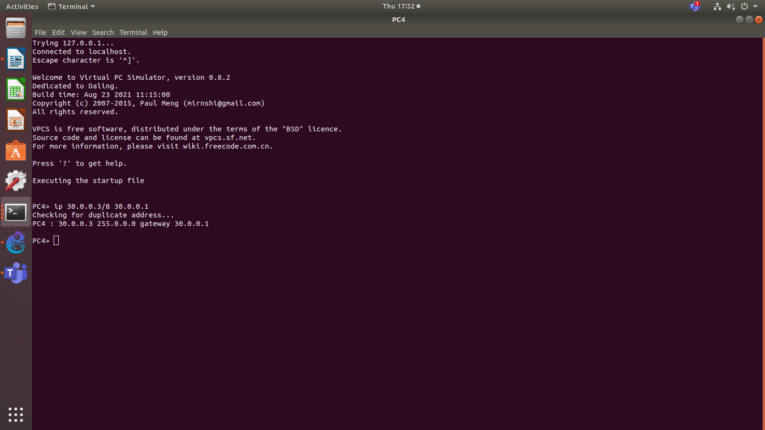

Pinging PC1 from PC3:
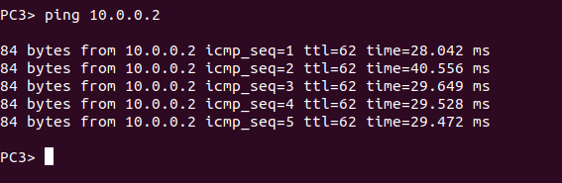

Wireshark capture which shows ICMP messages which means that the communications between PC1 and PC3 is successful.
